A Technical Project Report

On

**GROCERY APP -USING KOTLIN**

**IN ANDROID STUDIO**

**SUBMITTED BY**

**DEVARAPU SATYAVENI**

**UNDER**



**DATE OF SUBMISSION: 25_SEPTEMBER_2022**

**INDEX**

CHAPTER 1: Introduction

1.1 Abstract.................................................................................1

1.2 Objective...............................................................................1

CHAPTER 2: Background & Diagrams

2.1 Background...........................................................................2

2.2 Studies....................................................................................2

2.3 Challenges..............................................................................2

2.4 Context Diagram...................................................................3

CHAPTER 3: Requirements

3.1 Software................................................................................4

3.2Hardware...............................................................................4

CHAPTER 4: Implementation and Designing

4.1 Home Page.............................................................................5

4.2 Pop Up....................................................................................5

CHAPTER 5: Conclusion and Future Scope

5.1 Conclusion..............................................................................6

5.2 Future Scope..........................................................................6

**_________________________________________________________________________________________________s**

**CHAPTER-I**

**1.1 Abstract:**

ANDROID APP KOTLIN has been gaining popularity since it made its debut

Android Studio is an open and free which is used to develop the android application for mobile's, TV's, Watches and other Android OS, It provides leverage the power of SQL Database and build a app that shows items added by user.

**1.2 Objective:**

The goal of my project is making an app which store the user items in cart and user can modify and delete the added item in list. To develop a reliable system , I have some specific goals such as:

* Develop a system such that the user can add item details like product name, product Quantity and Product Price.
* Develop a database room which is used to store the user data which already added by the user in cart and user can also remove the previous added item in cart.
* Develop the good UI design which user friendly to user.
* Develop the good UI which is supported for all android devices.

----------------------------------------------------------------------------------------------------------------

CHAPTER 2

**Background & Diagrams**

**2.1 Background:**

Grocery app is a project that will help the user or admin to store the list of items in sequence order. If user want to add extra more items also possible and if user want to remove the previous items also available.

* UI DESIGN IN ANDROID PLATFORM
* ANDROID APPLICATION DEVELOPMENT
* DATABASE CONNECTION TO STORE USER DATA

**2.2 Studies:**

* Design user friendly environment
* Connecting database
* Add material icon for good UI
* Create the vectors and Material Colors
* Navigation of user action from one page to another page

**2.3 Challenges:**

working with database friendly UI design for UX Gradle and SDK settings

**2.4 Context Diagram:**

Use Care Diagram of Admin

**ADMIN**

**--------------------------------------------------------------------------------------------------------------------**

**CHAPTER 3**

**REQUIREMENT OF COLLECTION ADN ANALYSIS:**

**3.1 SOFTWARE:**

The Software Package is Developed Using Kotlin and Android Studio. Basic SQL Commands Used to Store the Database

Operating System: Windows 11

Software: Kotlin and Java

Emulator: Pixel 4 (API 30)

**3.2 HARDWARE:**

RAM: 8GB RAM

ROM: 20GB

----------------------------------------------------------------------------------------------------------------------

**CHAPTER 4**

**4.1 HOME PAGE & LIST ITEMS:**

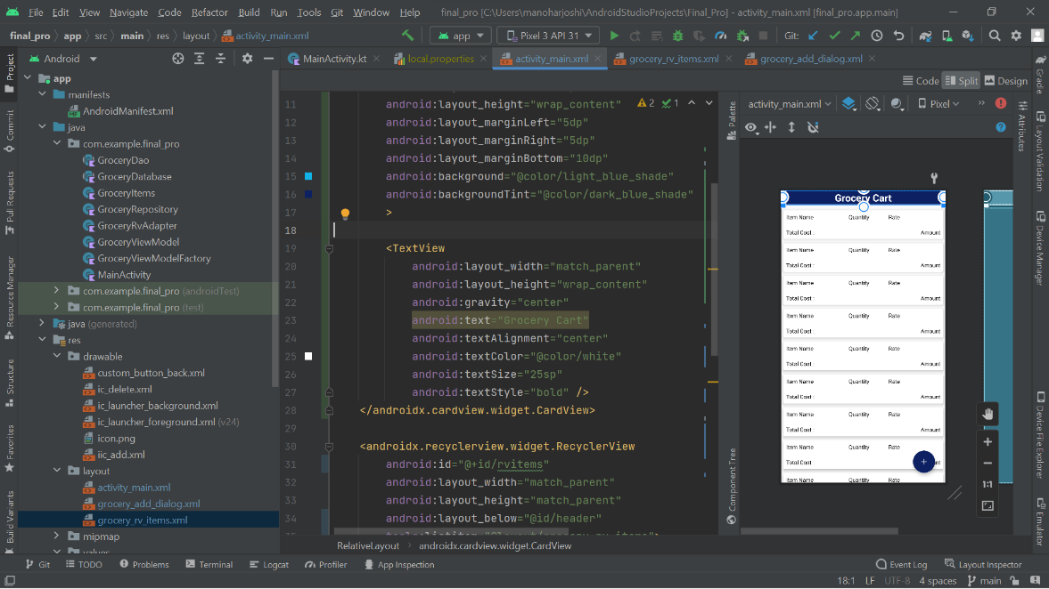

**4.2 POP UP PAGE**

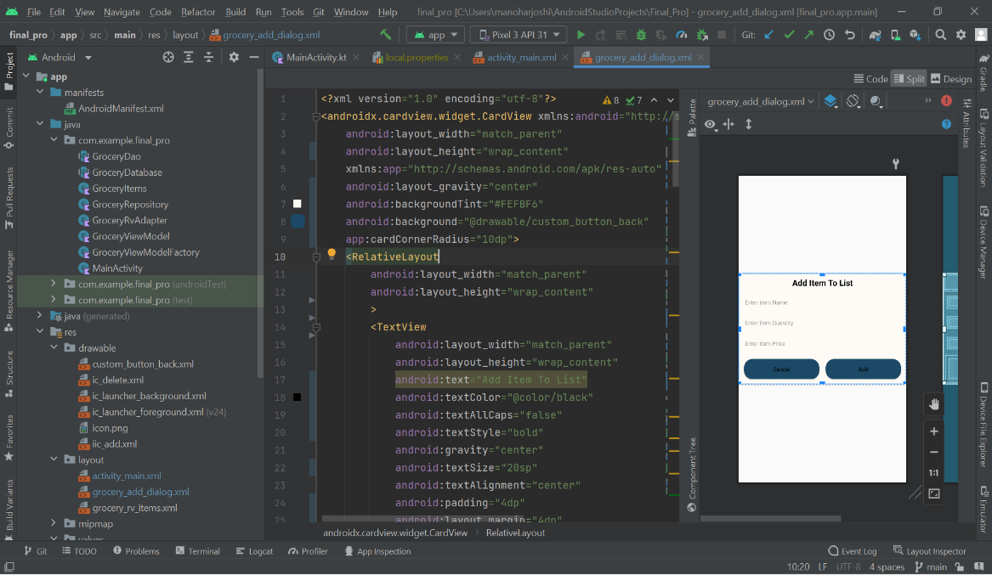**:**

**---------------------------------------------------------------------------------------------------------------------**

**CHAPTER 5**

**5.1 Conclusion:**

This application will help to store the list of items date include name price and quantity. Most of shopping admins want to store the his data in list, the application is very help full for them. Not only in shops and admins also helpful for user what they buy and what they want to buy.

**5.2 Future Scope:**

This application help to store the list of items by Admin. In Future we can also add user panel which is add by user required item that are submitted to admin

The Feature are:

* Add User Panel
* Add Admin Panel
* Provide Login authentication
* Add image to user product and rating